EXP NO:08 DATE:
Troubleshoot of a Malfunctioning Rectifier Circuit
Aim
To analyze a malfunctioning rectifier circuit and to identify faults and troubleshoot to restore proper operation.
Apparatus Required
- Faulty rectifier circuit (Bridge or Half-Wave)
- Digital Multimeter (DMM)
- Oscilloscope
- Function Generator (if needed)
- DC Power Supply
- Load Resistor
- Soldering iron and solder
- Spare diodes, resistors, capacitors
Theory
A rectifier converts AC voltage into DC voltage using diodes. A malfunctioning rectifier can be caused by various issues, including:
- Open or shorted diodes
- Faulty transformer or connections
- Burnt or loose components
- Excessive ripple due to capacitor failure
Procedure
Step 1: Visual Inspection
- Check for burnt or broken components.
- Inspect for loose connections or solder joints.
Step 2: Voltage and Current Testing
- Power off the circuit and measure the continuity of the diodes using a multimeter in the "diode" mode.
  - A good diode should show low resistance in one direction and high resistance in the other.
  - A shorted diode will show low resistance in both directions.
  - An open diode will show no conduction in either direction.
- Power on the circuit and measure input and output voltages.
  - Compare with expected values for proper rectifier function.
Step 3: Waveform Analysis Using an Oscilloscope
- Connect the oscilloscope probes across the rectifier output.
- Observe the waveform shape:
  - A working rectifier should show a rectified waveform.
  - An open diode may cause missing pulses.
  - A shorted diode may result in AC leakage.
Step 4: Checking the Filtering Circuit
- If excessive ripple is observed, test the capacitor using a multimeter in capacitance mode.
- Replace faulty capacitors if needed.
Step 5: Troubleshooting & Correction
- Based on the findings, replace defective diodes or capacitors.
- Re-solder loose connections and re-test.
Observations and Results
- Note the measured voltages and compare them with theoretical values.
- Record oscilloscope waveforms and analyze irregularities.
- Identify the root cause of the malfunction.
Circuit Diagram

Bridge Rectifier
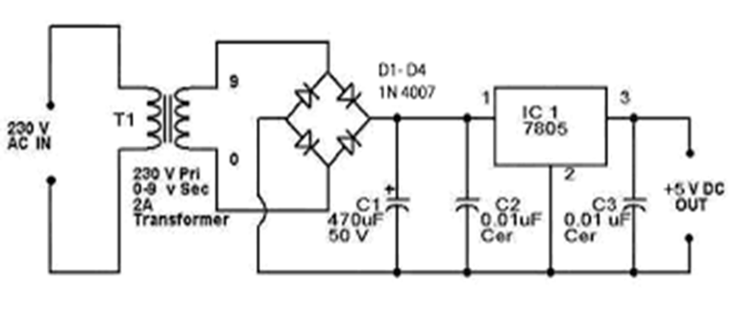
MODEL GRAPH
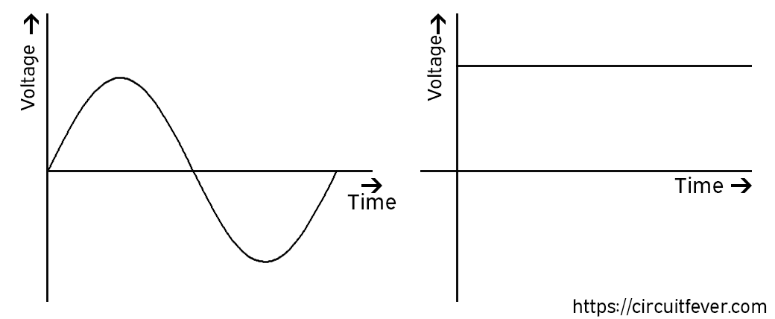

Result
Thus the analysis of a malfunctioning rectifier was done and the faults were identified. The circuit was troubleshooted to restore proper operation.

